Rapid Response Worksheet

Why this matters
Taking advantage of rapid response situations is key to narrative change work. Breaking stories capture the public’s attention. When the winds are behind them, a spark can quickly become a wildfire that reconfigures the narrative landscape. If we’re prepared in advance, we can disarm toxic narratives or harness breaking stories to advance our narratives. This worksheet provides a framework for responding doing just that. We encourage you to take some time now to practice using it on rapid response scenarios you anticipate arising in your work. (For example, if you work on environmental issues, consider preparing now for how you might respond to the next oil spill, wildfire, or storm.)

About the tool
Below, you’ll find a planning tool designed by Hattaway Communications in partnership with Narrative Initiative. This tool allows you to think about how to engage specific audience(s) that are strategically important in a rapid response scenario. It could be your own members, a specific set of people in your community, or key persuadables who you hope to persuade away from toxic narratives toward adopting healthy narratives. Following that, you’ll find a sample of how you might use the tool in a real-world situation.

Anchoring your response in core narratives
Whether you are trying to pivot away from a toxic narrative or take advantage of a breaking story to move our narratives, we encourage you to name the core narratives you hope to advance in every piece of work your organization is doing around a particular issue. As an example, we're sharing several narratives used by our partners at Our Minnesota Future.

Example Narratives | Your Narratives
Minnesota does best when we have compassion for one another, especially for our neighbors who are most in need.
Minnesotans do best when everyone in our community is thriving, including the natural world we inhabit.

Sample Rapid Response Worksheet
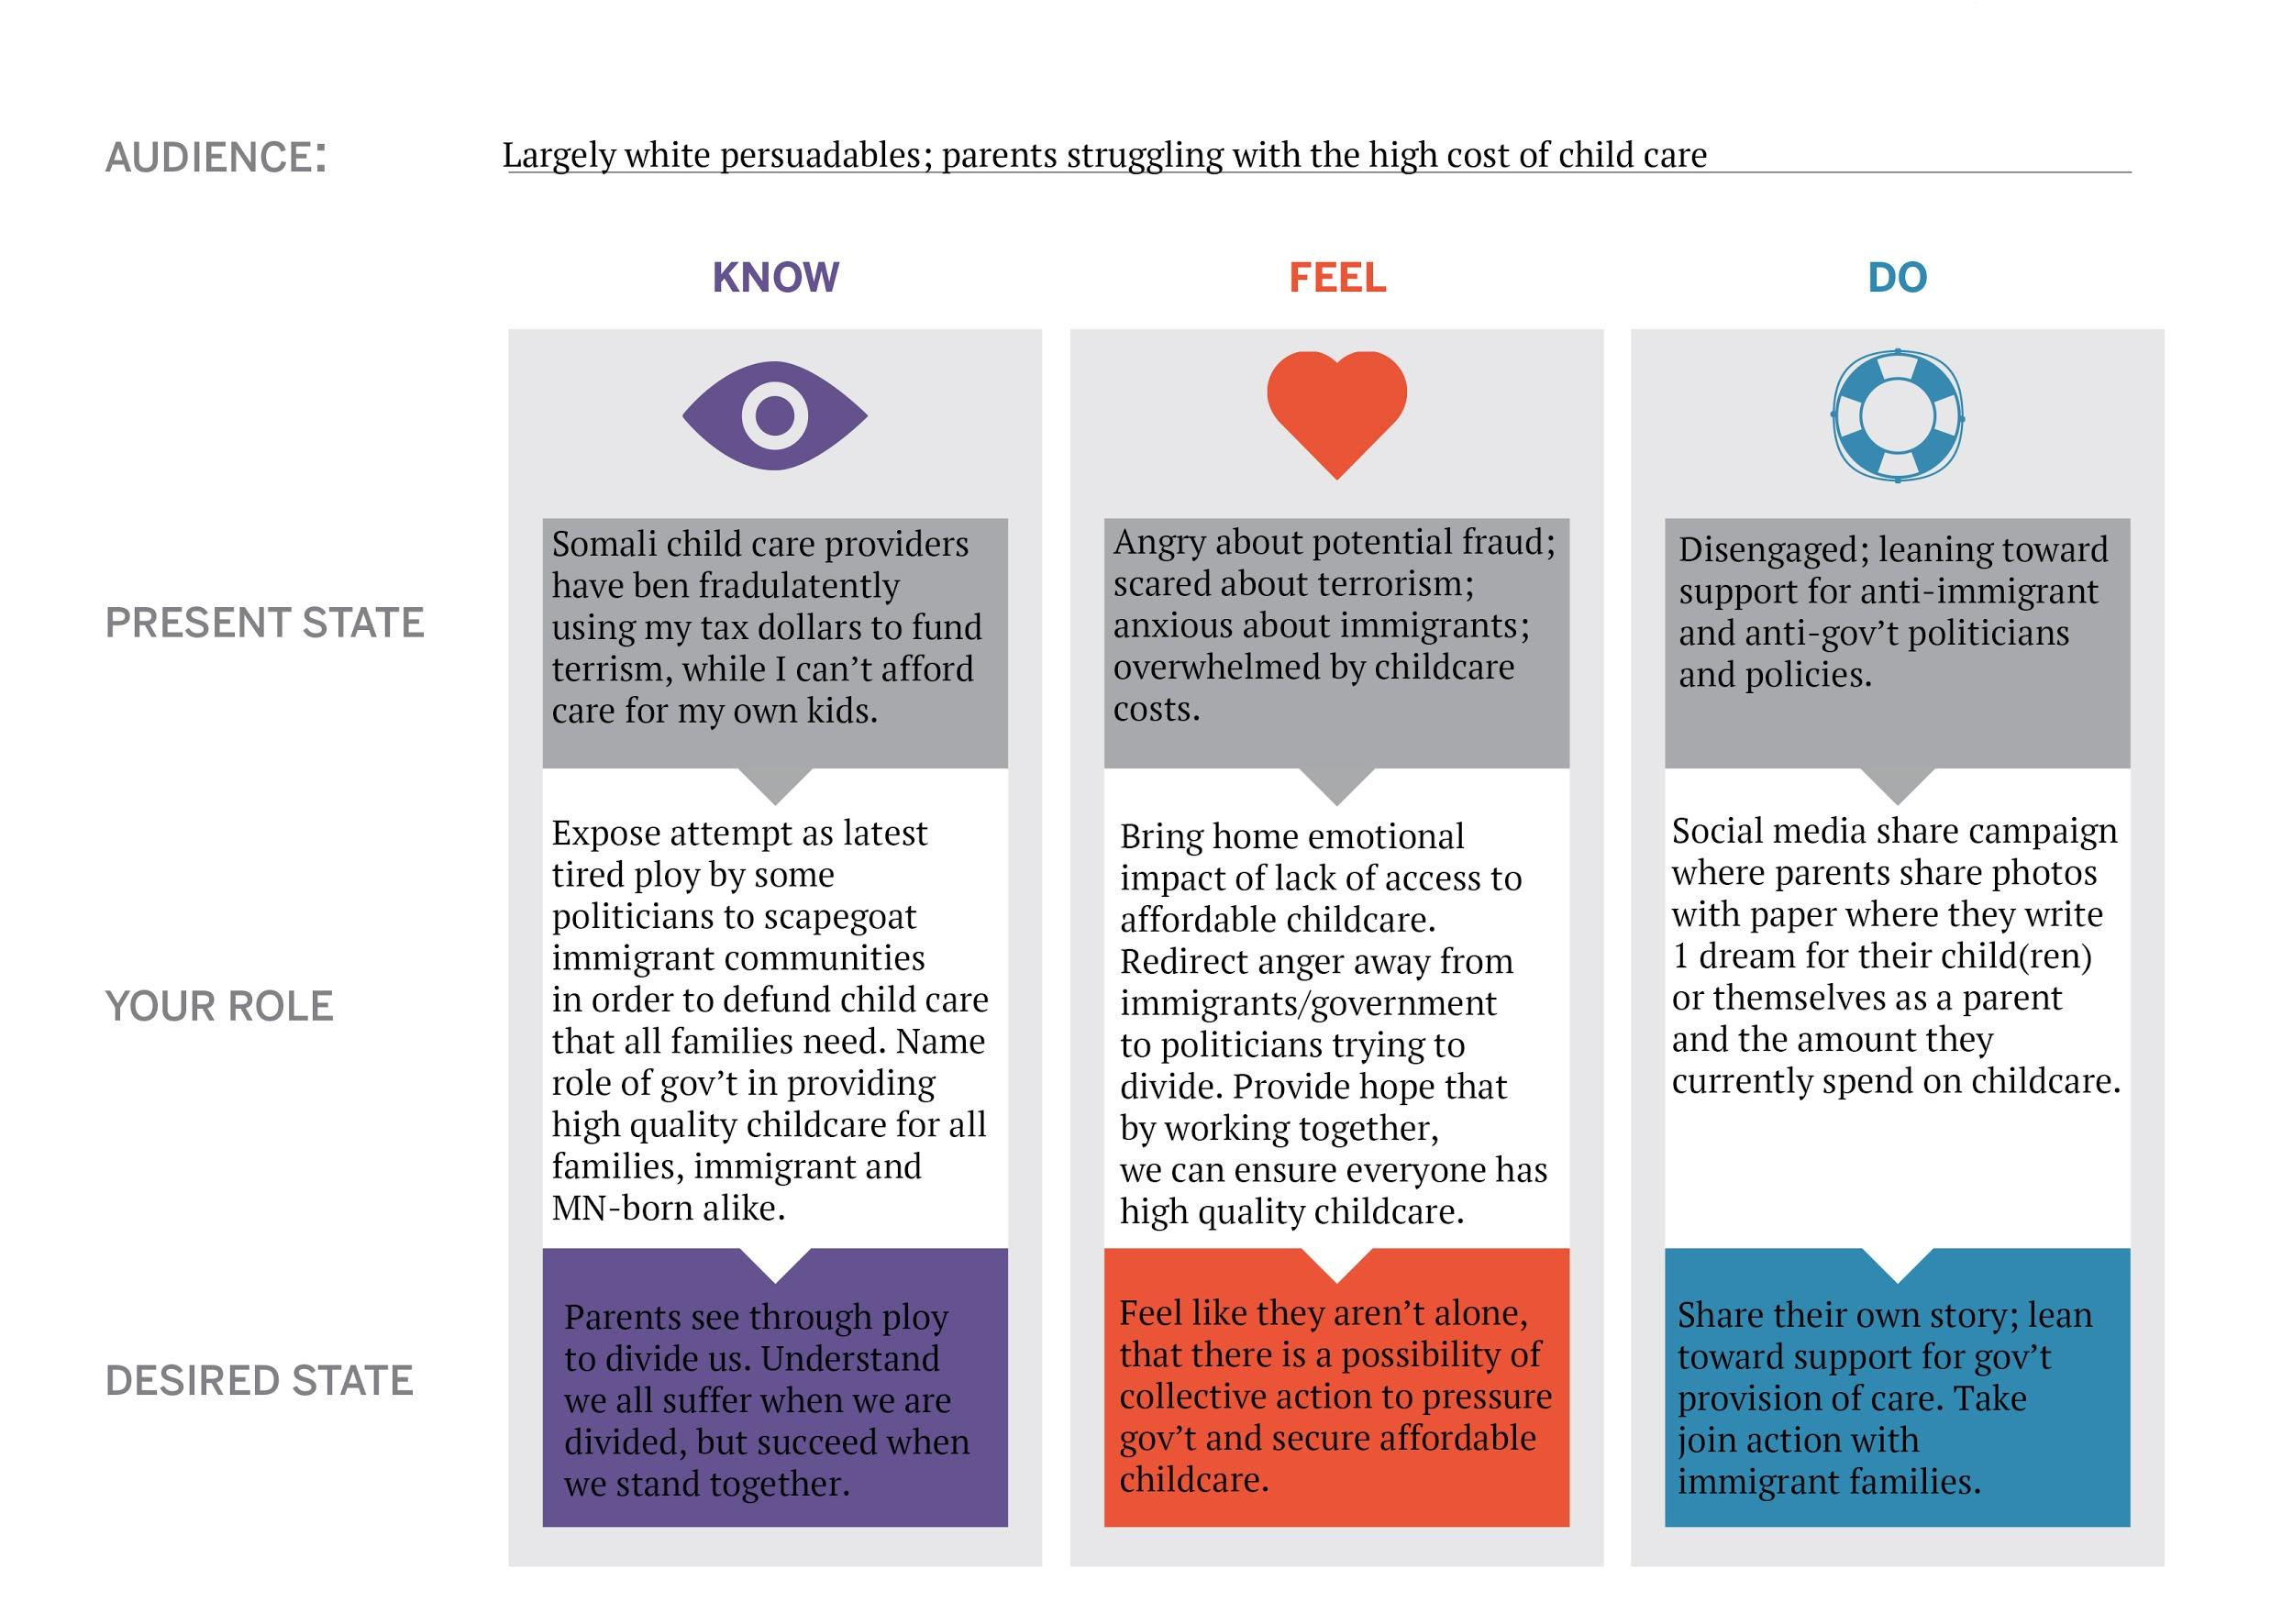
Scenario: Fox9 does a special report alleging that child care centers operated by Somali immigrants have defrauded the
government of $100 million and sent that money to terrorists.

A note on audience
selection: In this scenario and others, we may want to engage different audiences to take different actions. Here, we choose largely white persuadables, who are the likely target of political actors aligned with Fox9.

