My Palestine protest handbook
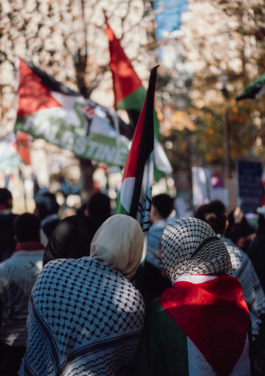
Image description: I am looking at a photo of people at a previous rally for Palestine.

Introduction
Purpose of this guide
This guide is here to help you understand what might happen at a pro-Palestine protest and how you can prepare to increase its accessibility and inclusivity for everyone.
What does this guide include?
Introduction 2
Before the protest 5
Understanding protests 5
Preparing what you might need 6
Understanding the start location 8
This is the route that the march will take 9
Finding public toilets 10
Understanding the people at the protest 11
Participants at the protest 11
Marshals 11
Medics 12
Legal observers 12
Police 14
Speaking to police 14
Being searched by police 15
Being arrested by police 15
Other people to be aware of at a protest 16
During the protest 18
What can I do? 18
What are some examples of call and repeat chants? 18
What should I be aware of? 19
What are tactics I can do to emotionally ground myself? 19
Box breathing 19
3-2-1 Sensory input 19
Pressing Palms 20
Other methods 20
End location 21
When the protest finishes 21
Points to remember 22
My space for notes: 23
Social Story: Going to a Palestine protest 24
Before the protest 24
Getting ready 24
People I might see 25
During the protest 25
If I need to calm myself 25
When the protest ends 26
Important things to remember 26
Photo credits: 27

How to use this guide:
- You can change the words, add photos, or draw pictures to make it work best for you or the person you’re supporting.
- It’s okay to skip parts that don’t feel useful. The goal is to feel ready and confident.
- Page 24 features a condensed social story that can be customised according to individual needs, based on the full guide.
Tips for editors:
- Swap in real photos of the location, police uniforms, friends, or items to bring.
- Keep sentences short.
- Use “I” statements so it feels personal and empowering
- Print it or keep it on a phone for easy reference.

Before the protest

Understanding protests
- I will be going to a protest to show solidarity for a free Palestine.
- This protest is organised by ______________________.
- A protest is when people gather together to show what they care about.
- Many people go to protests because they care about human rights and want to show leaders that Palestinians deserve safety, dignity, and freedom.
- If I have accessibility needs, I can contact the organisers for access information.
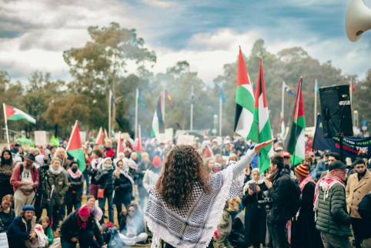
Image description: I am looking at a photo of people at a previous rally for Palestine.

Preparing what you might need
- I can go with friends, family, trusted people or by myself.
- I can bring sensory avoiding/sensory tools like headphones or ear plugs, sunglasses and sensory tools like a fidget by design object to help me regulate.
- I can wear a face mask. Depending on the state I’m in, police may have the authority to tell me to remove my face covering in certain situations. It helps to check the local rules ahead of time, so I know what to expect.
- I will prepare for the weather and bring sunscreen, an umbrella and jacket as needed.
- I may also wish to bring snacks and water, and electrolytes if required.
- Some people will carry flags and carry handmade signs.
- I can bring a flag or my own sign to carry. I can look at what other signs people have created and make similar ones.
- I can bring a fully charged phone (and battery pack if needed).
- I can bring mobility aid/s such as a portable stool/chair or a walking stick so I can rest when needed.
- I can bring hand sanitiser for myself and those with me to use.
- I can wear a sunflower lanyard to let people know I have an invisible illness if required.
- If relevant for me, I will print out emergency medical information, including details of my condition, medication, what assistance I need, and an emergency contact, and keep it in my pocket or bag.
- I will bring my Master Locksmiths Access Key (MLAK) if I have one so I can access accessible toilets if needed.
- I can use a trolley, such as a beach trolley or portable shopping trolley, to carry my things.
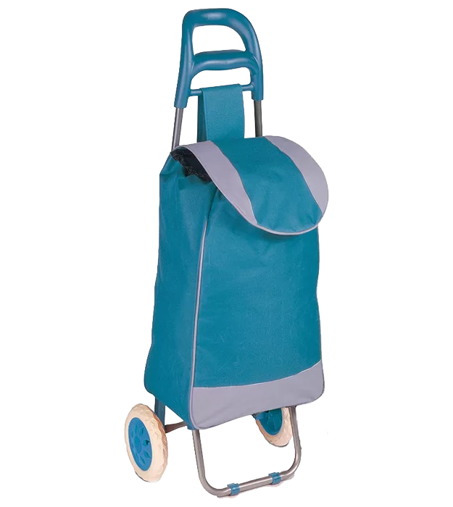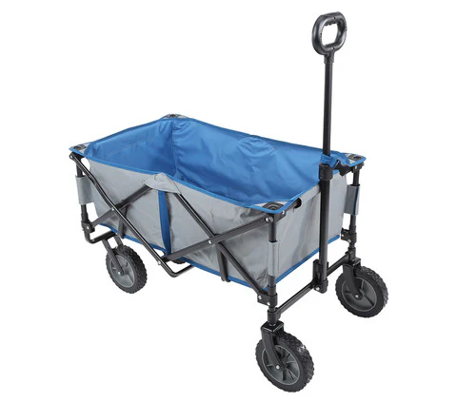
Image description: I am looking at examples of trolleys that I could bring to a protest.

Understanding the start location
I am looking at a map of __________________ where the march will commence at ___time and date_________. If there is a change in time or location it will be posted on the __insert Instagram account name____ Instagram and Facebook page the days before.
Oftentimes, the protest will have a meeting area for people with accessibility needs or aids such as wheelchairs or walking sticks, who then march together.
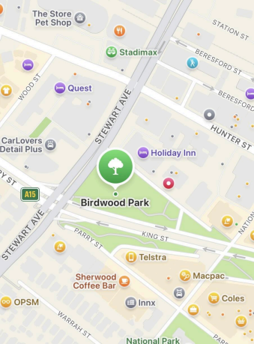
Image description: I am looking at a map of the starting location.

This is the route that the march will take
The march will commence from A __________________________and will finish at B__________________________________.
I will plan my route before I attend the protest, including where I might take rest stops. I might decide to meet the protest group at the finish point of the protest route.
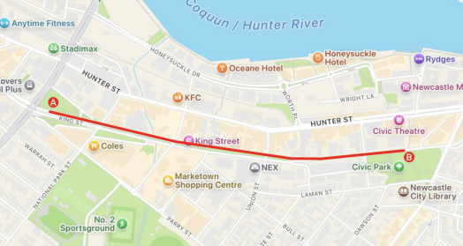
Image description: I am looking at a screenshot of the route the march will take.

Finding public toilets
https://toiletmap.gov.au this link provides information on publicly available toilets across Australia, including accessibility, opening hours and facilities like showers and baby change and sharps disposal.
I can find ones closest to me at any time by putting my location into the website.
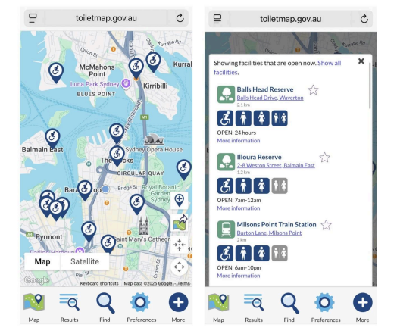
Image description: I am looking at screenshots from the toilet map website: https://toiletmap.gov.au

Understanding the people at the protest

Participants at the protest
- There will likely be First Nations’ Elders and community members or groups, and Aboriginal flags. Indigenous rights solidarity is generally strong between Palestinians and Aboriginal and Torres Strait Islander peoples, due to their mutual experience of genocide. They believe each other’s fight for land rights and human rights justice is a connected one.
- Palestinian groups will likely lead and/or be at the front of the march and it is important to allow them this leadership.
- People will have signs, flags, drums, megaphones and pots and pans.
- People will yell chants. It will be loud.
- People will be taking pictures and video on cameras and phones. Some of these images may be posted online. If I don’t want a picture or video of my face posted online, I should consider wearing a face mask or scarf over my face. I can decline if anyone asks to take a photo or video of me.
- There will be families, groups people,
- There will be a lot of people; I may be touched by people or items.

Marshals
There will be marshals at the event wearing fluro vests.
I will ask a marshal if I have any questions and follow the marshals and the crowd. If I need help at the event I can speak to a marshal and they can help or direct me.
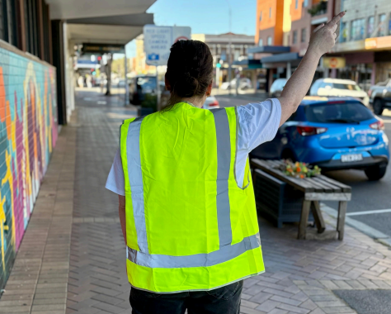
Image description: I am looking at a photo of a marshal wearing a fluro vest.

Medics
Medics will be wearing green vests or helmets, and I can seek help if I or someone near me needs medical assistance.
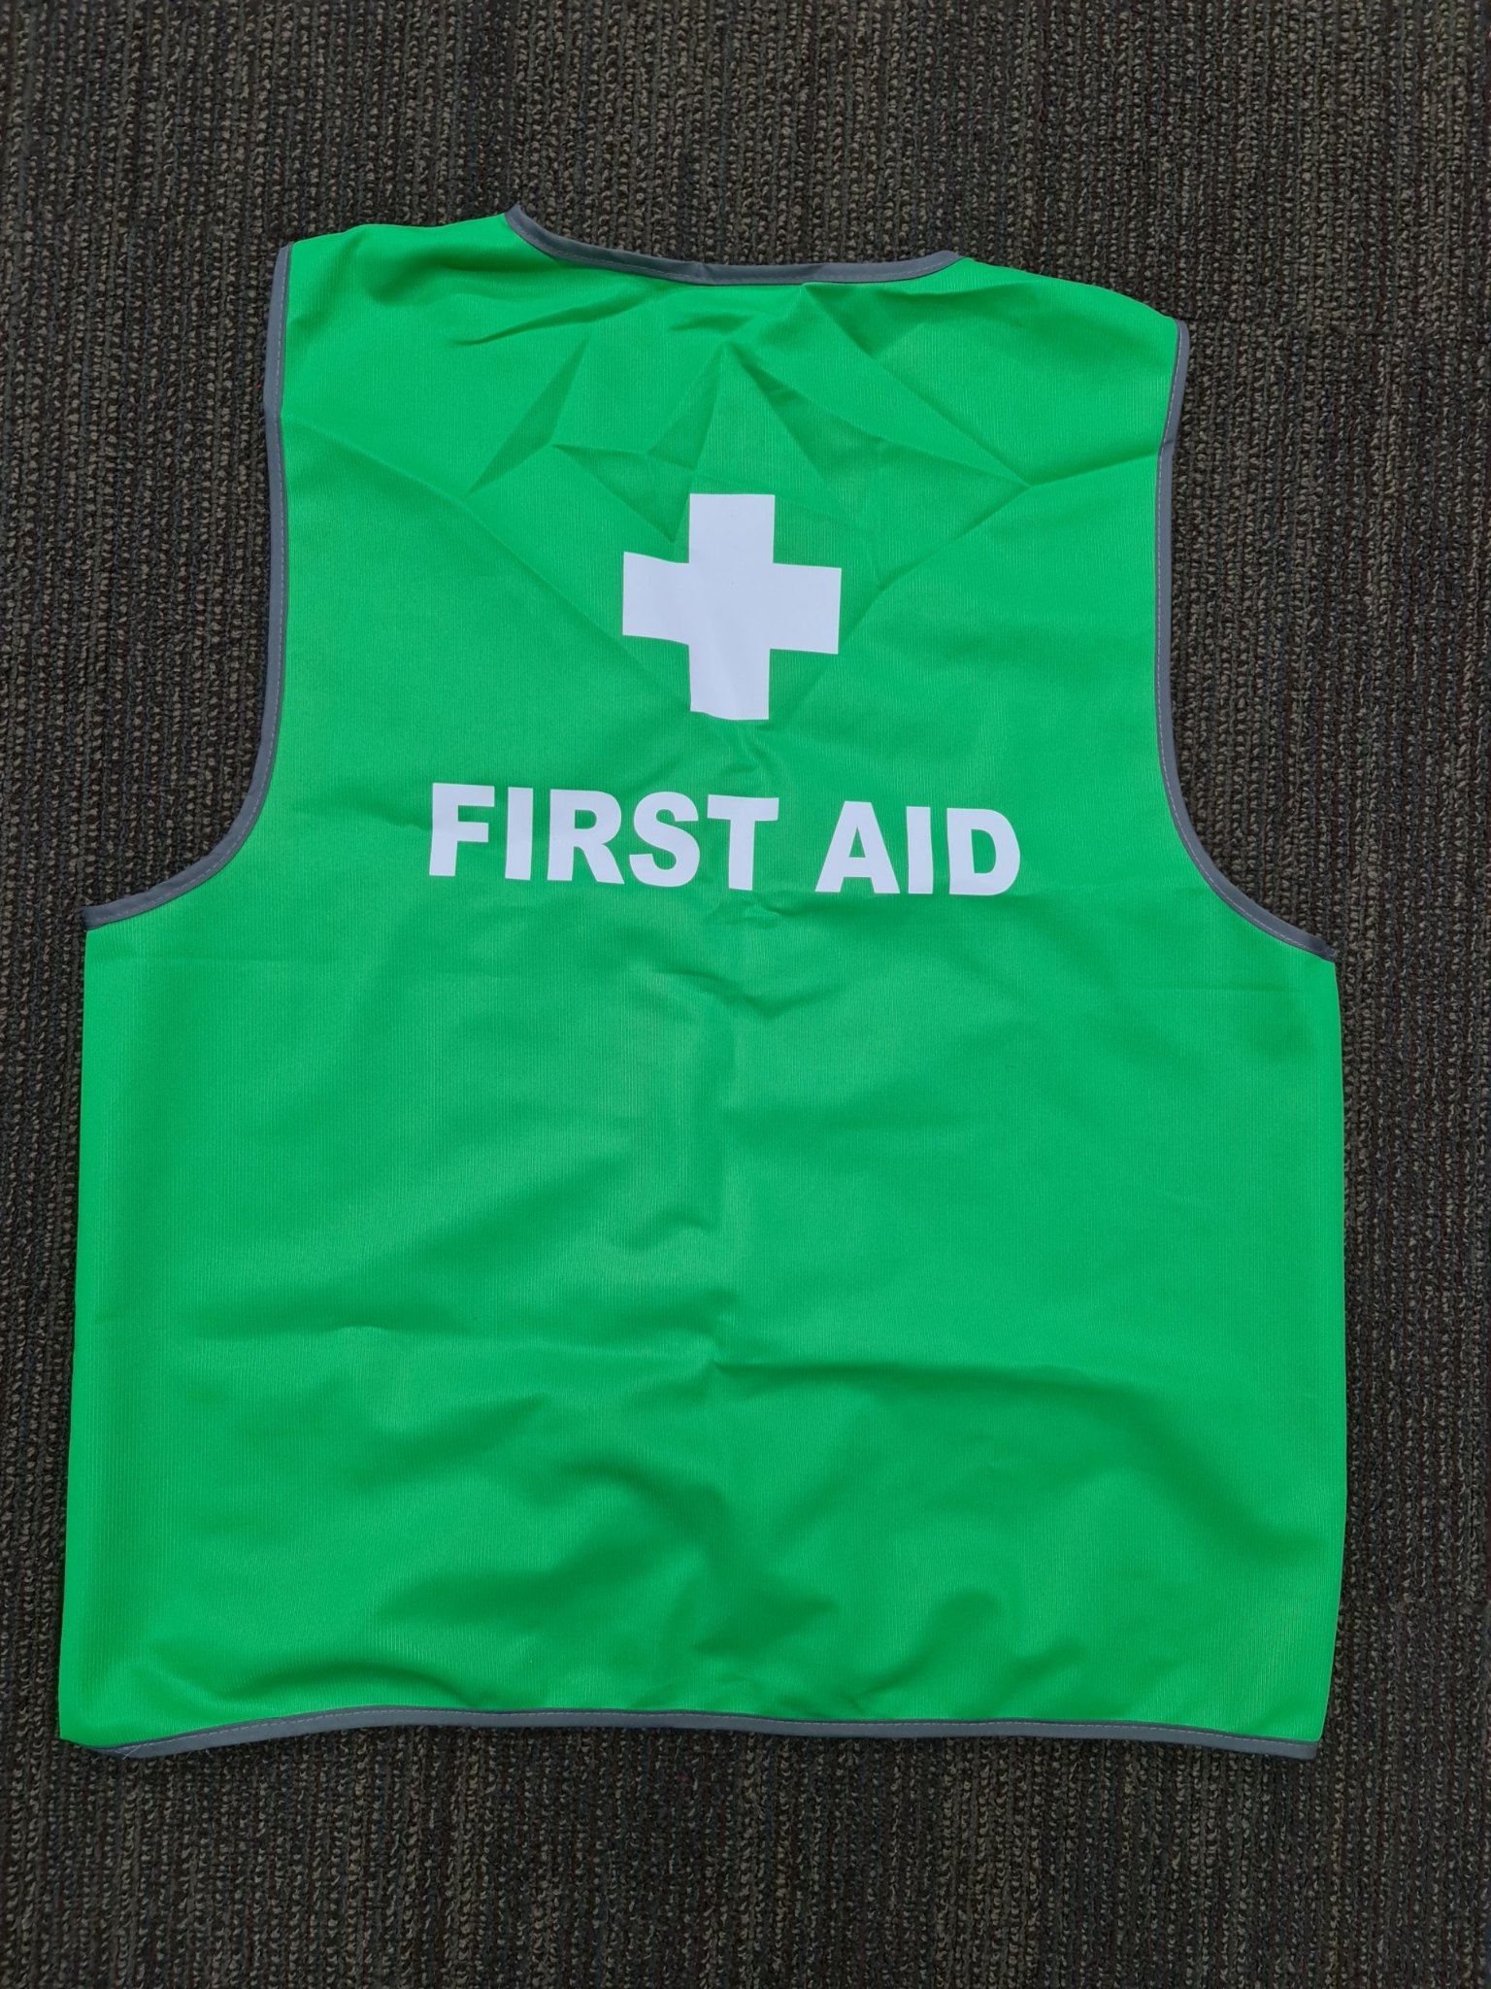
Image description: I am looking at photo of a green vest that a medic may be wearing.

Legal observers
There may be legal observers present. They will be wearing pink vests.
Legal observers do not take part in the protest itself, and are there to:
- protect supports the safety and rights of everyone participating in the protest
- ensure that police’s actions are transparent and accountable
- deter police’s misconduct.
Legal observers will:
- monitor and record police’s behaviour, including interactions with people participating in the protest
- documenting incidents like arrests, use of force, or other rights violations,
- use their notes and footage as legal evidence.
I can approach legal observers to:
- ask questions
- get a 'bust card' that has information about my rights if I am questioned or arrested by police.
I can get more information at www.legalobserversnsw.org or https://mals.au
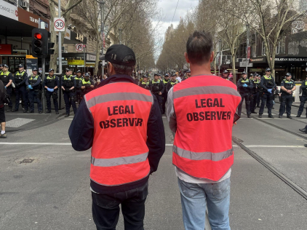
Image description: I am looking at a photo of two Legal Observers from Melbourne Activist Legal Support wearing pink vests.

Police
I will see police at this event, and they will march on the sides of the crowd.
I won't touch police for any reason.
Police may take pictures or video at the event without my consent. I can choose to cover my face with a mask, scarf and/or hat to prevent this. Depending on the state I’m in, police may have the authority to tell me to remove my face covering in certain situations. It helps to check the local rules ahead of time, so I know what to expect.
I can write a support person's name and number on my arm in case I lose my phone or am separated from my formal or informal support.

Speaking to police
I understand that police can ask me for my name and address, and I have to provide my real name and address to the police if the police:
- in Victoria believe I:
  - have committed an offence
  - I am about to commit an offence.
- in New South Wales if:
  - I am under arrest
  - the police intend to give a move on order
  - I am in a temporarily restricted area
  - the police suspect I can assist in an investigation of a serious offence.
I do not have to give police any more personal details, other than my name and address.
I have the right to silence, other than if I am in or near a police station then I must provide a reason for why I am.
I have the right to ask police and for the police to:
- answer “Am I under arrest?”
- answer “Why am I under arrest”
- action a request for them to “Can you write down your name, rank and station?”
I can get more information about speaking to police if I live in:
- Victoria at https://www.legalaid.vic.gov.au/speaking-police
- New South Wales at https://legalobserversnsw.org/wp-content/uploads/2024/10/kyr-nsw-general.pdf

Being searched by police
I have the right to ask police and for the police to:
- answer “Why am I being searched?”
- action request for them to “Can you write down your name, rank and station?”
I can get information about my rights about police searching me if I live in
- Victoria at https://www.legalaid.vic.gov.au/getting-searched
- New South Wales at https://legalobserversnsw.org/wp-content/uploads/2024/10/kyr-nsw-general.pdf

Being arrested by police
If I am not under arrest, I do not have to go with the police.
I have the right to ask police and for the police to:
- answer “Am I under arrest?”
- answer “Why am I under arrest”
- action a request for them to “Can you write down your name, rank and station?”
I have the right to:
- talk to a lawyer before and while the police interview me
- call someone I trust to let them know where I am
- (if under 18 or have a disability) have someone with me when police interview me
- ask for an interpreter if I do not understand English very well. This interpreter must be qualified, and the police will pay for it.
If I am arrested, the police may:
- ask for my name and address
- ask me to give a statement
- interview me
- fingerprint me
- search me
- ask to photograph me
- charge me
- charge me and give me bail.
If I’m arrested, the police will take my personal property. The police must list all the property on a property sheet, and then ask me to sign the sheet to agree what they have taken.
When I am released, the police will give my personal property back unless the personal property is being kept as evidence or they have destroyed it.
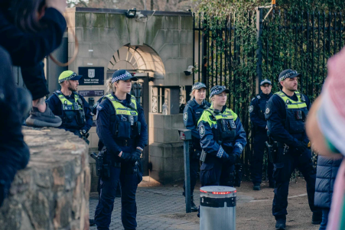
Image description: I am looking at a photo of Police standing to the side of a protest.

Other people to be aware of at a protest
- There may be people who are not supportive of the Free Palestine movement.
- They may attend the rally and try to attack or confront attendees.
- They may be wearing white and blue.
- I will ignore people with aggressive behaviour and find a marshal for assistance.

During the protest

What can I do?
- I can carry a sign if I want to.
- I can march, or I can stand and watch.
- I can leave whenever I want or need to.
- I can choose which parts of the chants to participate in.
- I can join in with a call and repeat chant. I have a choice not to participate.

What are some examples of call and repeat chants?
- Megaphone: “From the river to the sea”, Crowd: “Palestine will be free”
- Megaphone: “Free free Palestine”, Crowd: “Free free Palestine”
- Megaphone: “What do we want?”, Crowd: “Ceasefire”
Megaphone: “When do we want it?”, Crowd: “Now!”
- Megaphone: “In our thousands in our millions”, Crowd: “We are all Palestinians”
- Megaphone: “Israel, USA”, Crowd: “How many kids did you kill today?”
- Megaphone: “End the siege, end the siege”, Crowd: “End the siege on Palestine”
- Megaphone: “1, 2, 3, 4”, Crowd: “Occupation no more”
Megaphone: “5, 6, 7, 8”, Crowd: “Israel is a terrorist state”
- Megaphone: “Gaza, Gaza don’t you cry”, Crowd: “Palestine will never die”
- Megaphone: “The people united”, Crowd: “Will never be defeated”
- Megaphone: “Albo Albo you can’t hide”, Crowd: “You’re supporting genocide!”

What should I be aware of?
- People will yell loudly; there will be megaphones, drums, and people banging pots and pans.
- There will be a lot of people; I may be touched by people or items.
- There will be families, groups of people, individuals and pets.
- I may see protesters show various emotions, some may cry or look angry.
- I will not tone police other people on what they should or shouldn’t say, or how to express their sense of injustice. Let people feel what they feel.
- I will not peace police other people on what they should be doing. If a group of people are doing something that I am not comfortable with, I should move away from them.
- If I am feeling overwhelmed, I can stay towards the back or side/s of the protest group to try and give myself more physical space.

What are tactics I can do to emotionally ground myself?

Box breathing
- Breathe in for four counts
- Pause for four counts
- Breathe out for four counts
- Pause for four counts.

3-2-1 Sensory input
- Stand silently and notice
- 3 things I can see around me; (pause)
- 2 things I can hear; (pause)
- 1 thing I can feel with my body (pause).
- Take a deep breath and shake out my body to release tension.

Pressing Palms
- Place my hands palm to palm in front. (Can also move my palms out but keep my fingertips and thumbs touching, like a spider doing a pushup.)
- Press together firmly for three breaths.
- Release and shake out my arms.

Other methods
- Counting to ten (or five, or three, if time is of the essence).
- Self-encouragement, either out loud or silently: "I can do this,"
- Saying a short prayer, mantra, or phrase that has significance to me.
- Focusing on any neutral sensory input, like feeling the solid ground under my feet or the chair beneath me.
- Observing/naming my emotions so my can set them aside temporarily: "I feel angry, but for now I am going to project calm."
- Touching a ring, necklace, or other object I carry for its spiritual or emotional
- significance.
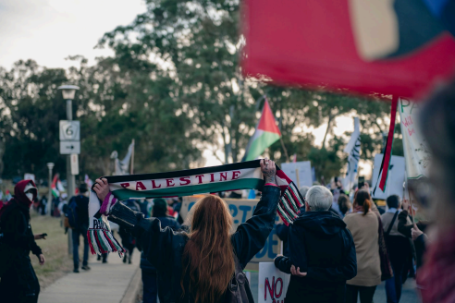
I am looking at a photo of protesters marching while holding signs and flags.

End location
When the march finishes at __________________________________, I can listen to speeches that will amplified with microphones and speakers. Or I can leave.
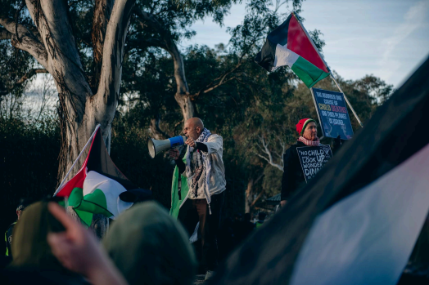
Image description: I am looking at a photo of a speaker talking into a megaphone.

When the protest finishes
- I can go home or do something relaxing.
- I might experience a range of feelings, for example, I might feel tired or proud. It can help to talk about how I feel with someone I trust.

Points to remember
- I am welcome here.
- I don’t have to do everything others do.
- Just being there shows support.
- I am part of a community that cares.
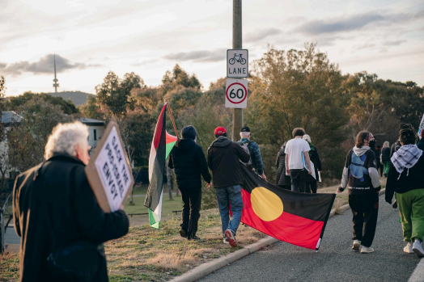
I am looking at a photo of a mix of people who are marching together at a protest.

My space for notes:

Social Story: Going to a Palestine Protest

Before the protest
I am going to a protest to show solidarity for a free Palestine.
A protest is when people gather together to show what they care about.
I can go with friends, family, trusted people, or by myself.
I can bring things that help me feel comfortable, like headphones, sunglasses, snacks, water, and a fully charged phone.
I can wear a face mask, but depending on the state I’m in, police may have the authority to tell me to remove it. It helps to check local rules ahead of time.
I can bring mobility aids or a trolley if I need them.

Getting ready
I will look at a map to see where the protest starts.
Sometimes there is a meeting area for people with accessibility needs.
I can plan my route and where I might rest.
I can also meet the group at the end point if that feels better for me.

People I might see
There will be many people, including families, Elders, Palestinian groups, and people carrying signs, flags, and drums. It may be loud and crowded.
Marshals wear fluro vests and can help me if I need support.
Medics wear green vests and can help with health needs.
Legal observers wear pink vests and watch police behaviour to protect people’s rights.
Police will be present. They may take photos or video.

During the protest
I can choose what I want to do.
I can march, hold a sign, chant, or simply watch.
I can leave whenever I want.
There will be loud noises like megaphones, drums, and chanting.
If I feel overwhelmed, I can move to the back or side of the crowd.

If I need to calm myself
I can try grounding strategies like:
- Box breathing (in for four, pause, out for four, pause)
- 3‑2‑1 sensory check (3 things I see, 2 I hear, 1 I feel)
- Pressing my palms together
- Saying something encouraging to myself like “I can do this.”

When the protest ends
When the march finishes, I can listen to speeches or I can leave.
Afterwards, I might feel tired, proud, or emotional. I can talk to someone I trust about how I feel.

Important things to remember
I am welcome here.
I don’t have to do everything others do.
Just being there shows support.
I am part of a community that cares.

Photo credits:
Canva - page 1.
Seshanka Samarajiwa - page 3, page 9, page 10, page 11, page 12.
Newcastle Mums for Palestine - page 7.
Melbourne Activist Legal Support (MALS) - page 8.

This guide was put together with love by Megan from Newcastle Mums for Palestine and Prue Stevenson, with contributions from Daniella Trimboli and Monique Tovo. We acknowledge the Traditional Custodians of the lands on which our work takes place across Australia. We pay our respects to Elders past and present and recognise the strength, knowledge, and sovereignty of all First Nations peoples. Always was, always will be, Aboriginal land.

