Introducing a new paradigm for social change
Andrew Gaines FRSA
Inspiring Transition
andrew.gaines@InspiringTransition.net
www.InspiringTransition.net
Our aspiration should be equal to the magnitude of our challenge.
You probably know the famous Einstein quote: You cannot solve a problem with the same thinking that produced it. I would say that this applies as much to the environmental-progressive movement as to anyone else. Our familiar modes of policy analysis, signing online petitions, and mass protests show no visible sign of actually changing business as usual.
True, we may be at a social tipping point regarding the reality of climate change. But relatively few people grasp the profound systemic changes necessary to actually deal with climate change. And besides, there are other civilisation-threatening trends as well. By failing to address the big picture, we activists, despite our local successes, are failing. Most major environmental statistics are getting worse.
If so, we would do well to be open to innovative approaches. Here I want to bring together strands from disciplines that are not usually considered by activists, and weave them into a new paradigm for social change that I believe has the potential to make the environmental-progressive movement orders of magnitude more effective.
Indeed, my deeper intention, with others, is to so profoundly change the operation of our society that we operate within planetary boundaries, and take care of people and the planet. So, it is actually not about being ‘more effective’. It’s about being so effective that we succeed in turning things around.
Contents
A life affirming culture | 1
The neurology of improving skilled performance | 3
Places to intervene in a system | 5
SCAN FOCUS ACT | 5
Citizen-educators and a movement for transformational change | 6
Evolutionary Activists | 7
Inspiring Transition | 8
Marketing | 9
The glass ceiling of aspiration | 10
The Inspiring Transition paradigm | 14
Sources of the paradigm | 15
A life-affirming culture
In the world of creative problem-solving the key thing, when faced with a challenging problem, is to accurately identify the problem to be solved.
I would say that the problem to be solved is to inspire mainstream commitment to doing everything required to reverse environmental trends, and evolve society that operates within the Earth’s capacity to support us.
It helps to have a positive goal. One way to put it is:
The challenge of our time is to transition to a life affirming culture, rather than continuing on our present course of ecological self-destruction.
Anthropologists tell us that every culture has a goal. The predominant goal of our globalised civilisation is economic growth. However, if we connect the dots we see that ever increasing economic growth requires ever increasing industrial production, and this drives environmental destruction. This cartoon sums up our situation:
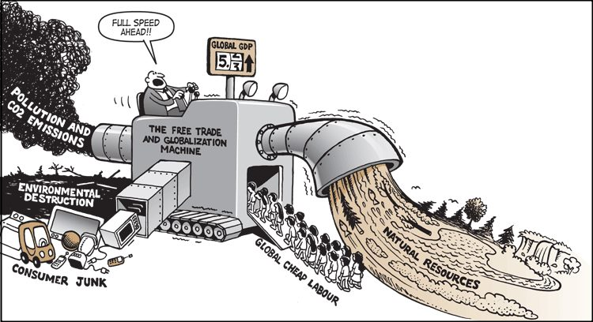
A life-affirming culture cares for people and the planet. It enhances the myriad of positive environmental and social initiatives that are already going on. Think of organic agriculture, renewable energy, improved child-rearing, reducing undue corporate influence on governments, and the like.
The prospect of changing the operating character of a whole society, or our globalised civilisation, can seem overwhelming. At first sight, it’s difficult to conceive how one would even approach the problem. In a moment, we will turn to that. There is a way.
But the first question is: is this the right problem?
Faced with a massive problem such as climate change (and given species loss, water depletion, toxins in the food chain, and the ever present possibility of nuclear war, our existential threat is much bigger than just climate change) it is natural for the mind to quickly jump to practical solutions.
Practical solutions are critical. However, I would argue that at present the sum of practical solutions will not suffice as long as the larger system is driving our destruction. We have to change the whole system.
The neurology of improving skilled performance
There is a saying:
To change the system, change the thinking.
This is because our behaviour is based on our ways of thinking. Let’s make this specific. All human behaviour is based on three elements:
- Our mental maps
- Our intention
- Our ways of going about achieving our intention (modus operandi)
In addition, people have psychological drivers. These can be distorted through many factors, including abuse in childhood or later. However, people have a core of compassion and caring.
Mental maps
In childhood our maps are restricted to the world we experience. Through reading, and now the Internet, our maps can expand far beyond our own experience. Although most people primarily pursue their personal interests, some look at the big picture and foresee the consequences of global trends.
A critical aspect of an approach to social change that has the possibility of being adequate to our challenge is to enable people to enlarge their maps in two aspects:
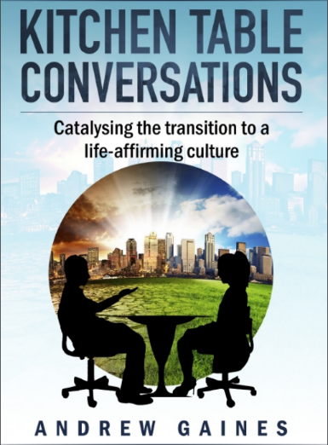
- Appreciating that humanity is in an existential crisis, with a number of trends that, if continued, will assuredly lead to the collapse of civilisation, possibly to virtual human extinction.
- Grasping the systemic nature of the changes needed to have a hope of things coming right for coming generations.
Kitchen Table Conversations is a tool for personal conversations that enable people to think this through. They equip people mentally and emotionally to support leadership for large-scale transformative change.

Intention
We have already mentioned that our predominant global intention is economic growth. Our proper intention is to transition to a life affirming culture.
Modus operandi
The term ‘modus operandi’ is used by the police to describe a criminal’s style of crime. Some break into houses, some embezzle, some do armed robbery.
The term is useful, because it focuses our attention on our modes of action.
Systems thinker Riane Eisler suggests that there are two fundamental modes of human relating. She calls them domination-control and partnership-respect.
Domination-control. Think of the millennia long history of military conquest, empires, patriarchy, slavery, bullying and indeed child abuse.
Partnership-respect. Think of parents who encourage their children to follow their own line of development; workplaces that give both autonomy and responsibility to their staff, or Gorbachev and Reagan negotiating to reduce nuclear weapons.
It comes down to this: as futurist Arthur Clarke said,
Any highly developed technological civilisation that develops weapons of mass destruction will destroy itself unless it evolves an ethos of collaboration for the common good.
Much of our society operates on domination-control values, where people try to impose their will on other people, primarily for their own self-aggrandizement. Arguably, for our own long-term survival we need to aim to embed partnership-respect relating as ‘the way things are done around here’ at every level from child-rearing to global governance.
There are ways to act on this. They involve experiential learning. Disciplines such as improvisational acting, Synectics, Aikido, and Conflict Resolution enable people to develop the skills of working collaboratively with other people.
In addition, we have psychological techniques that enable people to resolve the emotional disturbances that manifest as violence and abuse. Better yet, since often violence is often a consequence of child abuse, in some communities parents are voluntarily coached to bring out more of their nurturing side than their punitive side with their children.
Regretfully, we have evolved an economic system that stresses many people, and produces poverty pockets with high crime rates, street violence, a high proportion of single mothers, inadequate education, and poor job prospects. It is not just a matter of individual psychology. Desperate people do desperate things, and we have mass-produced desperation. In addition to the human cost, there is a financial cost to society. It would be less expensive overall to create the conditions of well-being – and even thriving – than to mean-heartedly pursue policies that lead to crime and violence.
Cultivating the inner conditions of well-being is essential for our survival. As a society we would do well to devote massive more resources to this. A more in-depth account is at Improving Brain Functioning – A New Paradigm for Social Change.
Places to intervene in a system
Systems thinker Donella Meadows wrote a famous essay called Leverage Points: Places to intervene in a system. In it she highlighted that the most influential place to intervene in any human system at the level of people’s paradigms and intentions.
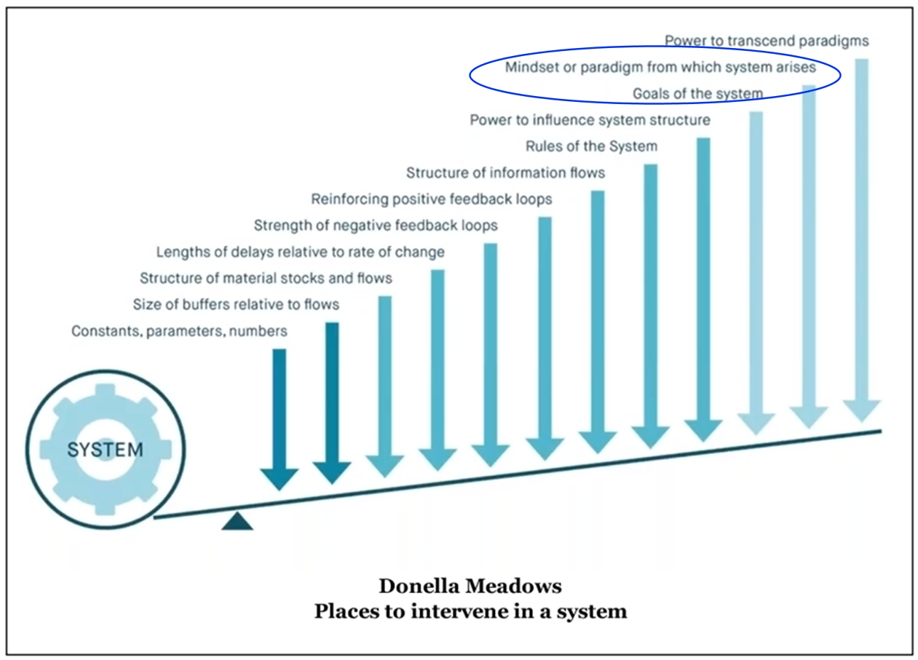
As mentioned, this boils down to the aphorism:
To change the system, change the thinking.
So, the heart of the new paradigm is improving people’s mental maps or frameworks understanding; championing a positive intention – transitioning to a life affirming culture; and embedding partnership-respect values as the predominant operating style of our culture.
In addition, we reduce the conditions of trauma, and give people support for resolving emotional issues.
In short, we aim to evolve a society based on human decency that operates within planetary boundaries. We have the means to do this; it is a matter of mobilising public will.
SCAN FOCUS ACT
Skilled problem-solvers in business, law and architecture typically go through a three-phase process which is sometimes called SCAN>FOCUS>ACT.
In SCAN you take the time to develop a big picture appreciation of your situation. Faced with a challenging problem, even though it is tempting, you don’t just jump to solutions. You take the time to consider the situation from many different angles. In architecture this could include considering the nature of the site, the expectations of the client, the style of surrounding buildings, zoning laws, and building codes.
This leads to the FOCUS phase where preliminary sketches are considered; one is selected.
In the ACT phase the building is designed in detail, so the builder and tradespeople know what to do. In other words, everything is thought through that enables the initial idea to be acted on.
The complete process of SCAN>FOCUS>ACT is rarely done in the environmental-progressive movement. Academics tend to stay in SCAN. They are great at analysing the problem.
In contrast, activists tend to bypass SCAN and jump right into FOCUS. They go for solutions. For example, climate activists get fired up about renewable energy or stopping coal mines. These are important, but they neglect the fact that the operation of the system as a whole make climate change worse… and climate change is only one factor that threatens the survival of civilisation.
More generally, whatever we advocate, it’s not enough just to ‘have a good idea’. Calls for action need to be supported by thinking through everything required to make them work… and then organising the needed commitment and resources.
One implication is that most of the conferences, World Café discussions, panel discussions and lectures about climate change are relatively ineffectual, because they mainly preach to the converted, and they do not enrol their audience in a cohesive movement to shift public consciousness. From the standpoint of this new paradigm, any gathering that talks about climate change or the Anthropocene, and does not ask the audience to be citizen-educators, is a missed opportunity for catalysing a movement.
But I’m a step ahead of myself here; I haven’t introduced the idea of citizen-educators yet.
Citizen educators and a movement for transformational change
The good news is that there are millions of groups that care about environmental and social well-being. Mostly the members of these groups pay dues, sign petitions, and sometimes protest.
Each member of these groups has their own personal network of friends, business colleagues and social media connections. And many are leaders of businesses or organisations in their own right, and the staff and members of these institutions also have their own broader networks.
The combined networks of all these people is quite large. However, the groups themselves tend to compete for attention, and the public hears a cacophony of voices. There is no unified message or common purpose among the groups, even though at a meta-level they all share similar values.
In contrast, the right-wing billionaires who oppose dealing with climate change and social justice, despite their diversity, are aligned in one overriding message and a shared point of view. They champion economic growth as one voice, and they oppose taxing the rich in the name of ‘liberty’.
The Koch brothers, famous for funding think tanks, seminars for potential politicians and judges, and right-wing grassroots groups (including some on university campuses) understood decades ago something that environmental-progressive movement has yet to grasp: the battle is about ideas.
The battle is to affect how people think. Understanding this, not only did they fund highly intelligent people who could articulate their ideology, they also gave thought to the distribution system: how to seed their ideas into mainstream culture.
Now it is true that they had billions of dollars that they were willing to spend. But much of what they bought with that money the environmental-progressive movement already has.
First off, we already have many of the ideas we need. Great thinkers such as Naomi Klein, Riane Eisler, Paul Raskin, David Korten and others have articulated the systemic changes we need. The steady state economy folks (CASSE), the New Economics Foundation, and others have well thought out ideas about how we can transition to a steady state economy.
Decades ago in Natural Capitalism Amory Lovins and his colleagues described design techniques that can reduce energy requirements by 90% or more, and they gave a multitude of practical examples drawn from architecture, industrial design, transport, agriculture and urban design.
Public health physicians have clear insight into the social determinants of health, and we have breakthrough techniques for greatly improving our mental health. And so it goes. In every significant area people have already done serious work and indeed, little reported in the public media, there is a great wave of positive change going on.
That said, I think that the great unsolved problem for the entire environmental-progressive movement is how to get out of our own thought bubbles, and engage people who do not read our books, watch our YouTube videos, or come to our lectures and rallies. Mostly, we preach to the converted.
The opportunity, given the huge cohort of people that care about environmental and social well-being, is for the members of groups to become citizen educators championing whole system change to a life affirming culture.
Evolutionary activists
Improving mental and emotional well-being is as important as technological changes in pulling out of our ecological nosedive. We must become the kind of people that can create and enjoy a life affirming culture.
Clinical experience shows that people who are emotionally clear tend to be open, curious, caring and compassionate. They are not readily manipulated by demagogues, because they don’t have the emotional triggers that demagogues can play on. They are not prone to violence, and they do not abuse their spouse or children. And they are not internally compelled to become excessively rich; they would rather spend quality time with family and friends, their own projects, and perhaps enjoying nature. Many care about the environment.
Research by Paul Ray and Sherry Anderson shows that there is a cohort of ‘cultural creatives’ who are naturally this way. And this is not surprising; at root we are decent human beings.
However trauma, and especially extreme trauma, interferes with this harmonious way of being. A massive percentage of our population are mentally disturbed to some degree, as evidenced by what psychologists call ‘normal marital sadism’, irrational interpersonal conflict in organisations, and the massive numbers of antidepressants and tranquilizers that are prescribed each year. And we have politicians, supported by the people that voted them in, who are simply cruel in their policies.
The good news is that there are a variety of psychological techniques that enable people to progressively resolve their emotional issues.
Cultivating emotional well-being is too important to be left solely to professionals. It is to be celebrated that mindfulness is now widely taught in both schools and in corporations, and practised by many people. The next step is to introduce people to techniques that can use for themselves to resolve their own emotional issues.
I call people who do this ‘evolutionary activists.’ I envision a movement of evolutionary activists introducing psychological self-help techniques to people they know. Potential evolutionary activists include people who have done some kind of ‘inner work’ through mindfulness, insight meditation or psychotherapy.
Sources of techniques that people can use for themselves include Gary Craig’s Emotional Freedom Techniques (EFT), one of the new energy psychology techniques; Jay Earley’s Self Therapy, a manual for applying Internal Family Systems Therapy to ourselves; and my own The Witness: Gateway to Self-Development. The level of facilitation skill required is not great. We are acting as trainers, not as psychotherapists. This is a ‘barefoot doctor’ approach.
Prevention is better than cure. A key leverage point for evolving a life-affirming culture is to raise kids without traumatising them. Local governments would do well to put resources into supporting young parents in bringing out more of their nurturing site and less of their punitive side with their kids. For example, Boulder Colorado has a volunteer Community Parenting Center where experienced parents support new parents. Twelve years after the program started teenage crime rates were markedly lower compared with previous years.
Inspiring Transition
Be The Change Australia has set up Inspiring Transition as a support platform for self-initiating citizen educators. It a support platform for a movement. As such, there is no central group that directs what people do. Everyone who participates, whether as an individual, a business, or an NGO, acts as an autonomous agent.
We are aligned in our commitment to communicating to inspire mainstream commitment to transitioning to a life affirming culture. How we go about that is up to us. However, communication tools to get started, including Kitchen Table Conversations, are available through the Inspiring Transition website.
Marketing
Marketing does not necessarily require massive amounts of money.
Marketers emphasise the importance of having your brand seen ‘everywhere’. Of course, the environmental-progressive movement does not have a common brand. As mentioned, we have a cacophony of voices.
However, perhaps we can make common cause around the meme of transitioning to a life affirming culture. This stands in contrast to economic growth as the defining goal of our time.
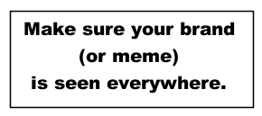
The simplest thing citizen-educators can do in terms of marketing is simply to use some version of the phrase We are transitioning to a life affirming culture at every opportunity. Thus, it can be mentioned in talks and lectures, brought up in personal conversations, and woven into blogs and articles.
Business websites can assert that their business (e.g. solar panels) is a contribution to the evolution of a life affirming culture. Likewise, businesses can put plaques and flyers saying they support the evolution of a life affirming culture in their waiting rooms.
Once we have grasped the paradigm of whole system change to a life affirming culture, a marketing strategy is to get on as many talk shows and interview programs is possible. The more of us that do such things, the more the idea of transitioning to a life affirming culture will gain traction. Let’s talk it up!
Outreach
If you embrace the goal and communication strategy that I am putting forward here, perhaps the most effective thing you could do is to contact influential people and introduce them to the idea. We build a movement by engaging more and more leaders.
In preparation, it would be useful to conduct a few Kitchen Table Conversations with people you know. That way you would gain experience in articulating the ideas.
I find this slide deck helpful when I talk to people on Zoom. It’s easy to go on to share screen and take people through the ideas. Catalysing Mass Commitment to Transformational Change is virtually a manual for how to do this. The first one or two times you take somebody through it (again, practice with a friend) you can just go through the slides in order. They make sense that way.
Later you will be able to make it more of an open conversation, and skip to different slides as appropriate. Zoom plus the slide deck are a great combination!
The glass ceiling of aspiration
To me, the idea of championing whole system change to a life affirming culture, and communicating to inspire mainstream commitment, seems almost like common sense, once we get the idea. Why wouldn’t we champion a positive vision?
Well, apparently there are reasons to not champion the idea of transitioning to a life affirming culture. Although some people resonate with the idea right away (we have an international network of colleagues), in my experience many people shy away from it. Here’s how it works.
We start with the idea that many groups can make common cause in the overarching goal of transitioning to a life affirming culture.
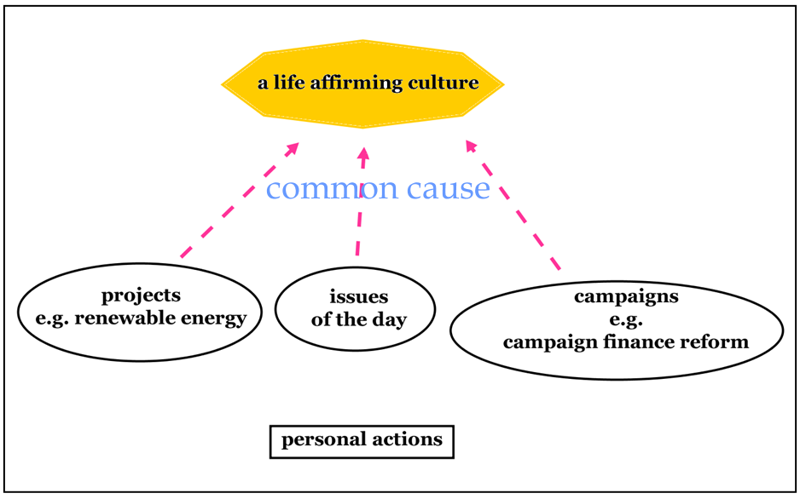
However, I have observed that as conversations get close to the possibility of embracing that goal, for one reason or another often people’s minds divert away. It is as though there is a glass ceiling of aspiration that limits the scope of the vision we will embrace.
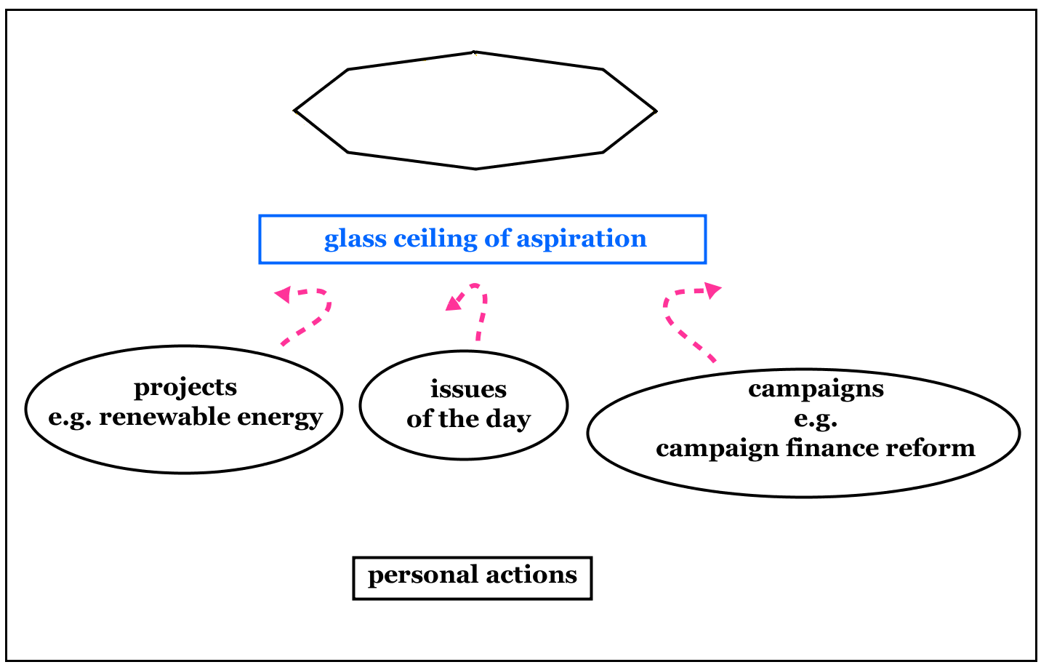
Why diverge? Given real concern about environmental and social trends, why shy away from embracing the goal of transitioning to a life affirming culture?
I suspect that there are several levels of dynamics.
1. One is the sheer magnitude of the task: it seems impossible. And indeed, it may be impossible. The odds are against us.
However, I’m encouraged by the fact that there is a huge cohort of ‘cultural creatives’ who care about the environment, and who are not obsessed with making excessive amounts of money. And as Paul Hawken put it in Blessed Unrest, there are millions of groups that care about environmental and social well-being. And many people accept the reality of climate change.
2. Everybody has commitments. There is an understandable fear that getting involved with Inspiring Transition will require too much time.
We are not asking for a massive commitment. Our communication tools are straightforward to apply, and do not require an inordinate amount of time.
That said, sometimes the ordinary course of our lives gets disrupted, and we are required to extend ourselves. It happens in war. Today we are in an ecological emergency of monumental proportions, and collectively we must go all out to turn things around.
3. If you have worked primarily on local projects, as many of us have, it is a bit of a mind stretch to grasp the whole system. This can tap into the part of people that feels, “I don’t know enough.”
It’s not hard to get the rough overview. We do not have to be experts, even though to a degree the more we know the better.
4. I suspect that some people shy away from embracing the goal of a life affirming culture because embracing the goal would put them in touch with their underlying despair. Therefore they feel more psychologically comfortable working on local projects where they can see results, even though at some level they know that overall we are failing.
The desire to avoid feeling despair is certainly understandable.
5. People do not want to be seen as proselytising.
Having conversations about adverse environmental trends, and the systemic changes needed to change course, is not basically about proselytising. It is about responding constructively to our existential emergency. We do this by helping people come to grips with the reality of our situation, and enabling them to think for themselves.
However, there is an aspect of proselytising or salesmanship. We are encouraging people to accept the language of ‘transitioning to a life affirming culture’ as a shared goal. This language is not necessarily the best. I doubt that there is a ‘best’ language. However, it’s good enough. It does the job, and many people resonate with it. Let’s get on with it.
6. Talking about serious topics, and especially undertaking to help people think better, can feel uncomfortable because it breaks social conventions.
The way to start is to invite a friend to spend time with you having a serious conversation. If they accept invitation, you have an agreement. Some people will welcome the chance!
7. In addition, there is the simple fact that the Inspiring Transition approach is an unfamiliar way of thinking, and each of us already has our own way of thinking which we are attached to.
It is appropriate that we should be attached to our own thinking; of course we should value what we do. At the same time, we do well to be open to new approaches.
8. And then, dismally, we may have attachment to being seen as the source of wisdom, the font of knowledge, the expert. If so, it does not serve our egos to support other people in becoming leaders… unless they are doing ‘our’ program. ‘Not invented here’ can come into play.
To sum up, enrolling colleagues in a movement to inspire mainstream commitment to evolving a culture that takes care of people and the planet is not necessarily easy. It may take a number conversations, and a certain adroitness in helping people grasp a new way of thinking.
Why bother? Well, this brings us back to our starting point. Unless we change the operation of our whole society to operate on life-affirming values, our doom is certain.
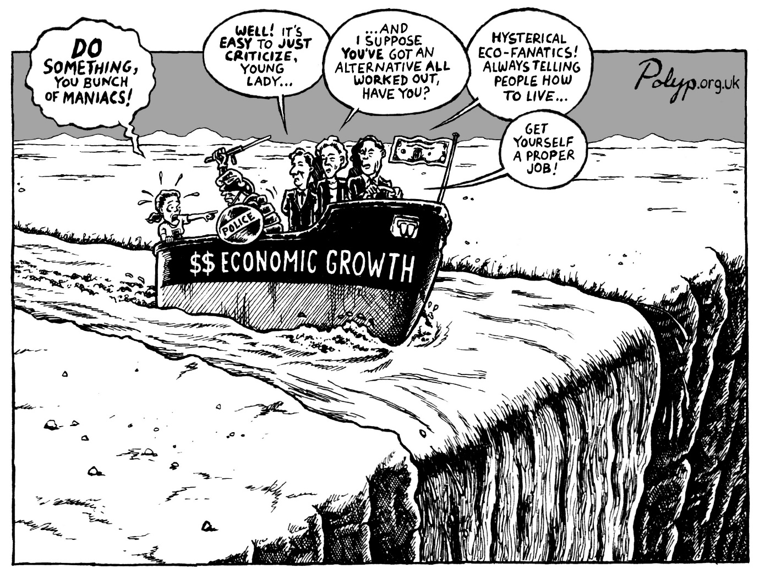
Therefore we should penetrate through the glass ceiling of aspiration, and wholeheartedly embrace the goal of transitioning to a life affirming culture.
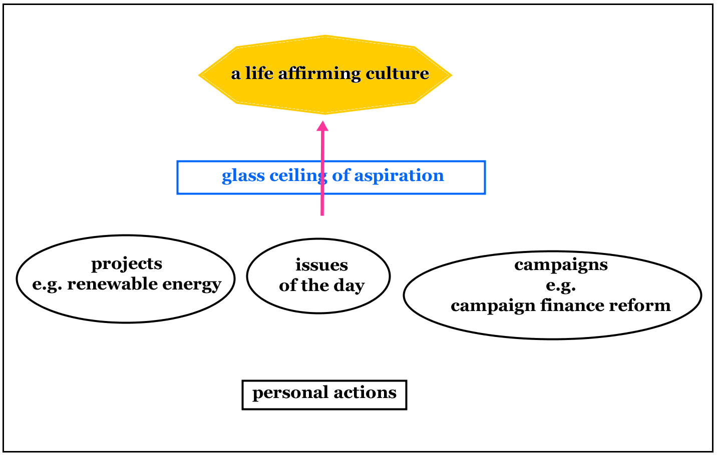

The Inspiring Transition paradigm
The Inspiring Transition paradigm includes these elements:
- Enabling people to think better. People’s behaviour is based on their:
  - Maps, or frameworks of understanding.
  - Intention.
  - Modus operandi; their way of going about realising their intention.
- A positive goal: transitioning to a life affirming culture.
  - Operating on partnership-respect values.
  - Operating within the Earth’s capacity support us.
- A delivery system to seed the goal into mainstream thinking.
  - Inspiring the members of groups act as citizen-educators.
  - Inspiring people who have done ‘inner work’ to act as evolutionary activists.
  - Encouraging public intellectuals to champion whole system change to a life affirming culture.
- Providing a set of communication tools to get started with.
  - Kitchen Table Conversations
  - Psychological self-help tools
  - Sample emails
  - Guerrilla marketing tactics
- No central group that directs what people do
  - Each individual or group acts autonomously.
  - We are aligned in our commitment to the goal,
  - And in the recognition that communicating to engage mainstream commitment is essential for success.
The Inspiring Transition website is maintained by Be The Change Australia.

Sources of the paradigm
Modes of thinking that are integrated into this new paradigm include:
□ Donella Meadows Leverage Points: Places to intervene in a system.
□ Insights into the neurology of improving skilled behaviour pioneered by Moshe Feldenkrais. The tagline is: We help good brains work better.
□ Breakthrough techniques in the fields of psychotherapy and energy psychology that enable people to rapidly resolve emotional issues.
□ The DesignShop process of SCAN>FOCUS>ACT for thinking through complex issues to the point of action.
□ The idea of ‘solving the right problem’ from the world of creative problem-solving.
□ The Natural Step principles for working out whether a company or a nation is ecologically sustainable or not.
□ Design techniques from Amory Lovins and the Rocky Mountain Institute for reducing energy demand.
□ Insights from effective marketers.
□ The recognition that the members of the millions of groups that care about environmental and social well-being are a hugely untapped resource for transformative social change.
□ The goal of ‘transitioning to a life-affirming culture’ was adapted from eco-philosopher Joanna Macy.

Aligned, the environmental-progressive movement can be far more powerful than we ever envisioned. Or so I suppose. Let’s put it to the test!
www.InspiringTransition.net

