A STAKEHOLDERS’ GUIDE TO THE SENATE

Contents
INTRODUCTION TO THE SENATE 3
THE LEGISLATIVE PROCESS 6
The Stages of a Bill 6
TOOLS OF THE SENATE 8
Motions 8
Order of Production of Documents 8
Disallowance 9
Matter of Public Importance Speeches – MPI (Daily Debate on an Urgent Issue/s) 9
Private Senator’s Bills 9
Questions without Notice 9
Adjournment Speeches 10
Consideration of Documents, Committee Reports, Ministerial Statements and Government Responses 10
Suspension of Standing Orders 10
Petitions 10
OUTSIDE THE CHAMBER 11
Committees 11
Estimates 12
GLOSSARY 13

INTRODUCTION TO THE SENATE
This guide is intended to be an introduction to the Senate and its procedures rather than a comprehensive resource. It is designed to give NGO staff an understanding of the basics of the Senate and how to best achieve policy and campaigning goals.

More information on Senate practice and procedure can be found online at http://www.aph.gov.au/About_Parliament/Senate/Powers_practice_n_procedures/odgers

The Role of the Senate
The Parliament of the Commonwealth of Australia, or the federal Parliament, is made up of two houses— the House of Representatives and the Senate. Both are directly elected by the people of Australia.

The functions of the Senate are to represent the states equally and to review the proposals and decisions of the House of Representatives and the executive government.

Equal representation of the states was intended by the framers of the Constitution to protect the less-populous states, Western Australia, Tasmania, South Australia and Queensland, against the possible domination of the more prosperous and more populous states of Victoria and New South Wales.

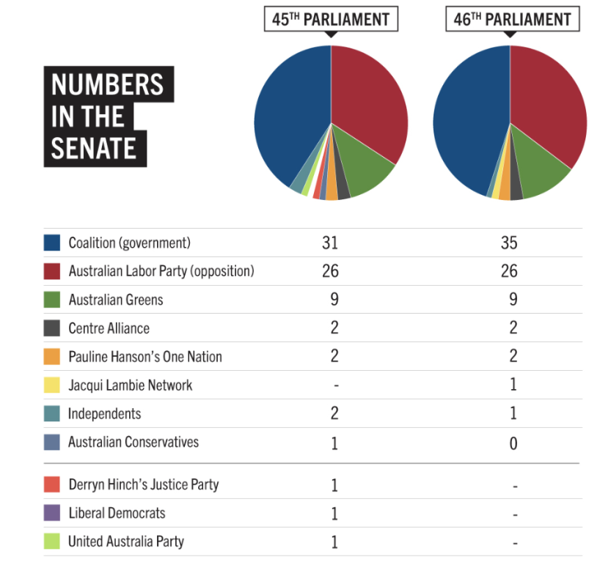
Who’s in the Senate?
There are 76 Senators; 12 from each state & 2 from each territory.

Senators are elected for a 6 year term. There is a half-Senate election every federal election.
In the current Senate, no party has a majority on their own so negotiation is essential to get anything done. The Greens, along with the 10 others on the crossbench hold the balance of power and can have a strong influence on whether or not legislation is passed.

The Senate needs 38 votes to block and 39 votes to pass any legislation. This means:
- For the government to pass anything in the Senate it needs Coalition (35) plus 4 votes.
- For the non-Government parties to block government bills, you need 38 votes: Greens (9) + Labor (26) + 3 crossbenchers.
- For non-Government parties to pass our own bills or motions you need Greens (9) + Labor (26) + 4 crossbenchers.

The House of Representatives

The House of Representatives is generally considered the main game in politics for most of the media and the public, because the Government is formed in the Lower House. Most Government Bills originate in the House, and it is a requirement for appropriation Bills to originate in the House. Until recently, independents and minor parties have not had a significant foothold in the House, and as such NGOs have more chance of influencing policy outcomes through the Senate.

Where to focus your lobbying attentions

The relevant portfolio holders (either House or Senate) of the Coalition, ALP and Greens are critical to achieving any policy or campaigning goal in the Senate. If the issue crosses over different portfolios, lobby all portfolio holders.

Local members where there is a strong constituency relating to the issue, particularly where those MPs are representing a marginal seat.

The crossbench Senators – they are critical to passing or blocking anything.

Senate Scheduling
The order of proceedings in the Senate is governed by a series of Standing Orders. SO 57 provides the Routine of Business which is outlined below. This is a guide only as the Senate is able to resolve to suspend Standing Orders and rearrange business at any time prior to adjournment. The Routine of Business can be found here: https://www.aph.gov.au/Parliamentary_Business/Chamber_documents/Senate_chamber_documents/Senate_Routine_of_Business. Prior to each sitting week a draft agenda is provided giving an indication of the legislation the Government would like to deal with in the week ahead.

The Senate Order of Business (known as ‘The Red’) is produced each day as a guide to the proceedings of the Senate. The online version known as the Dynamic Red provides the most up to date information on the agenda for each sitting day and can be found at http://www.aph.gov.au/Parliamentary_Business/Dynamic_Red.

Occasionally there are Senate-only or House-only sitting weeks. If you want to focus your lobbying on Senators, aim for a Senate-only week as they are less busy. Budget week, and the weeks before the Christmas and winter breaks are always hectic and it can be difficult to secure meetings.

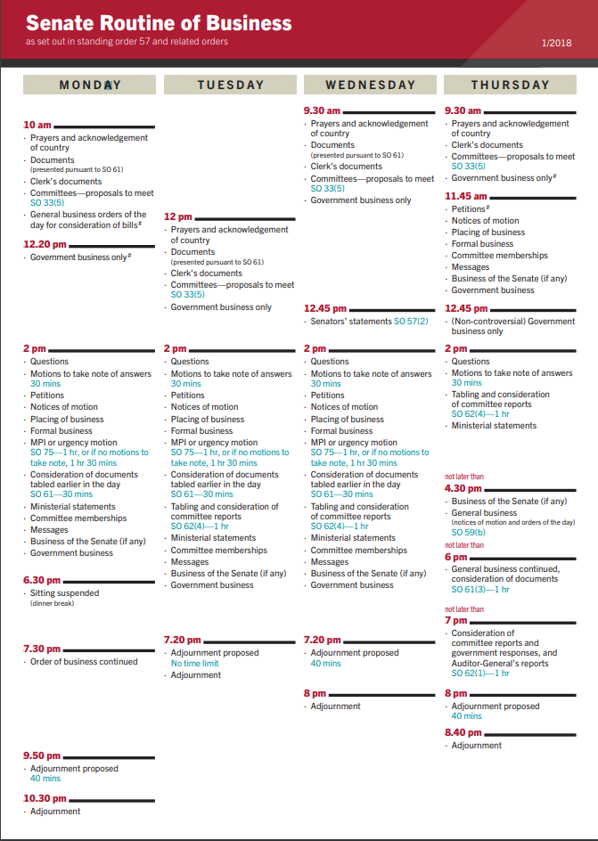

THE LEGISLATIVE PROCESS
Proposed legislation is known as bill as it proceeds through parliament. Once it’s passed it’s called an Act. A bill can be introduced in the Senate or the House of Reps. Bills are usually introduced by the Minister responsible for the portfolio or a Parliamentary Secretary representing them. The majority of bills are introduced in the House of Reps and then sent to the Senate for concurrence.

To be passed into law, a bill must pass both houses of parliament in the same form. This means that if the Senate amends a bill, it must be sent back to the House of Reps for consideration of the proposed amendments. Many of the crossbench parties, independents, and even occasionally the ALP, will wait until a Bill reaches the Senate to finalise their position on a Bill.

The Stages of a Bill
There are many stages to the path of a bill through the parliament. Some are largely ceremonial, such as the First Reading, whereas others are key in deciding whether or not a bill will be passed. The key stages of the path of a bill are outlined below.
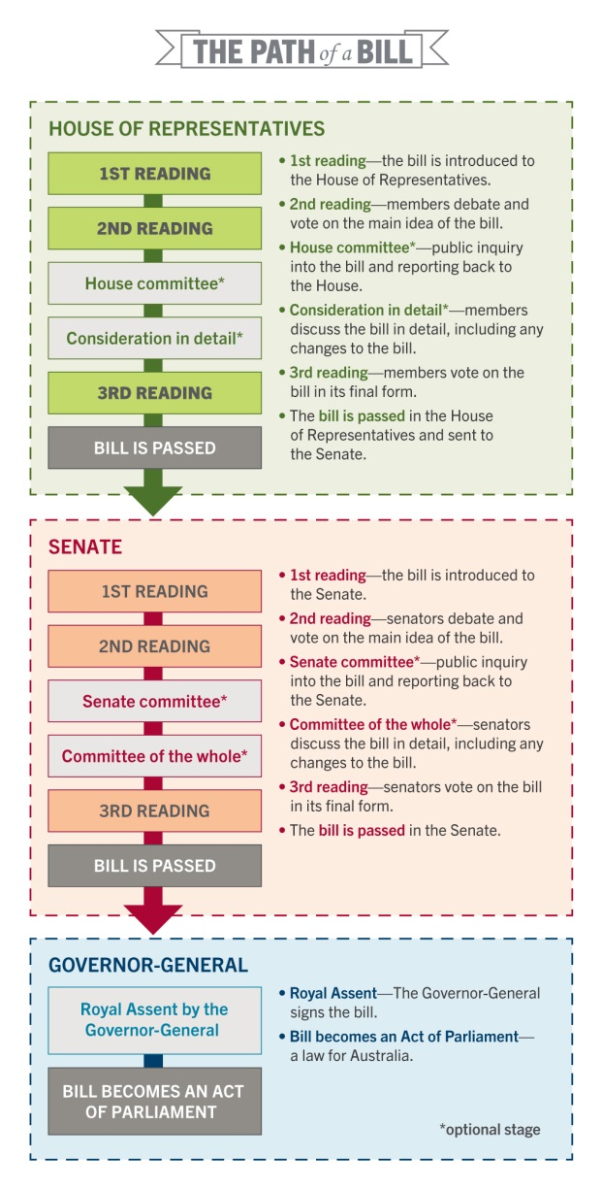

Senate Committee Inquiry
The Senate may refer any bill to a legislation committee for a public inquiry into the provisions of the bill. The role of the committee is to look deeper into the proposed legislation and what its effects would be if enacted. Committees may hold public hearings that provide an opportunity for the public and stakeholder groups to put their opinion on a bill on the public record. Following their inquiry the committee reports their findings back to the Senate.

Second Reading Debate
The “second reading” debate is one of the most significant stages of the law making process. It is when the Senate considers the principles of the bill and decides whether to accept or reject it in principle, and when Senators express their views about the bill and whether it should be passed.

During the second reading debate each senator has the right to speak for up to 20 minutes on the bill but cannot speak more than once.

The second reading speech of the Minister responsible for introducing the bill is particularly useful, as this is when the minister provides the justification and argument for the bill. The second reading debate is concluded when the minister responsible wraps up the debate and summarises the arguments in favour of the bill.

Senators may move a second reading amendment during the second reading debate. Unlike amendments moved later in the Committee of the Whole, second reading amendments do not change the text of the bill. Although they are occasionally used for procedural matters such as referring the bill to committee, second reading amendments are usually used to make broad political statements about the contents of the bill. These second reading amendments take a similar form to a motion and express the Senate’s view on an issue.

The Minister will then move that ‘the bill be now read a second time’. At this point the Senate decides if they would like the bill to proceed to the next stage where it can be amended.

Committee of the Whole
Following the passing of the second reading any senator can request that the Senate goes into Committee of the Whole, where any senator may speak for up to 15 minutes as many times as they choose. Senators often use this time to ask the minister specific questions about the bill and its provisions or move amendments to the bill.

During the Committee of the Whole stage, senators are able to move substantive amendments to the bill. For an amendment to pass it must be agreed to by a majority of senators. Some amendments require 38 Senate votes to pass, and some require 39 votes to pass. This is because some amendments are effectively phrased in the negative, so to support the amendment Senators have to vote “no”. Often it is hard to anticipate which amendments will be phrased in the positive and which in the negative.

Amendments must be related to a Bill’s long title, which is generally very broad, for example: “A bill for an Act to amend the Competition and Consumer Act 2010 and for related purposed”. The recent passage of the so-called Medevac Bill actually consisted of amendments to the Home Affairs Legislation Amendment (Miscellaneous Measures).

The term “splitting a bill” can refer to several different procedures. A Senator can split a Bill by opposing parts of the bill (usually schedules) in the Committee of the Whole stage. Or sometimes a party or Senator may negotiate with the Government to split off a particular part of the bill into separate legislation. Lastly, a Senator can lodge a motion to instruct the Committee of the Whole to divide the bill (but the House will not agree to this type of Bill, so is not likely to succeed).

Third Reading
The third reading is the final stage of the bill where the senate chooses to either pass the bill as whole or reject it.

Tracking a Bill through Parliament
The bills homepage on the APH website is an extremely useful resource and hosts copies of each bill and its associated documentation (click the ‘bills’ tab on the APH website). The bill will appear with a second reading speech and explanatory memorandum and all related speeches and amendments. The homepage will sometimes have a bills digest created by the Parliamentary Library which outlines the history and context for the bill and is a very useful tool for helping to understand a bill.

All bills currently before the Parliament can be found at http://www.aph.gov.au/Parliamentary_Business/Bills_Legislation.

To search Parliamentary debate more generally, navigate to Hansard from the APH website. Their advanced search tool is very effective.

TOOLS OF THE SENATE

Motions
Motions are a proposal for a clear and succinct resolution or order of the Senate. They can be used to show the Senate’s support/condemnation for a particular issue, put a stance on an issue on the record or attempt to wedge particular parties or Senators.

Motions are voted on during Formal Business each sitting day (usually about 3.30pm) and must be submitted to the sub-table’s office the day prior.

Example of a notice of motion:
Senator Siewert (Western Australia ) I give notice that on the next day of sitting I shall move that the Senate –

- Notes that:
  - on Friday, 15 June 2018, the Hands Off Our Charities Alliance released a set of 'Red Line Principles' that provide guidance to Parliament in light of some recent government proposals around foreign involvement in Australian politics, and
  - the Red Line Principles provide a framework to enable Parliament to get the balance right in promoting and protecting public participation in our democracy while recognising concerns over improper influence from big business and foreign entities;
- affirms that it is critical that the ability of charities and not-for-profits to use funding for issues-based advocacy is not restricted; that there is a clear distinction between issues-based advocacy and politically partisan electioneering, which is already regulated in the Charities Act 2013; and that organisations do not face a greater compliance burden; and
- calls on the Government to:
  - support the Red Line Principles, and
  - work to ensure that any bill seeking to deal with the problem of covert foreign influence in Australia does not have unintended consequences, including adverse impacts on charities and on freedom of the press.

In proposing motions, it is important to consider the purpose: for example are you wanting to force parties to be on the record about a particular issue or simply promote your issue in a non-partisan way?

Order of Production of Documents
The Senate has the power to request that the government produce documents. An OPD is a way of setting a time frame for the government to make certain documents public. These are voted on and if the vote is passed the government must provide the documents, or supply reasons for refusal.

An Example of an order for production of documents:

Senator Ludlam to move on the next day of sitting:
That there be laid on the table by the Minister representing the Minister for Resources and Energy, no later than 4 pm on 11 March 2010:
- all reports submitted to the Federal Government by Parsons Brinkerhoff assessing and characterising proposed sites for a Commonwealth radioactive waste dump in the Northern Territory, including the final report submitted to the department on 18 March 2009, the CH2M HILL’s peer review and the Parsons Brinkerhoff’s response to that peer review;
- the anthropological report prepared by consultants, Mr Kim Barber, Mr Robert Graham and Dr Brendan Corrigan, for the Northern Land Council (NLC) and provided to the then Minister for Education, Science and Training (Ms Bishop) in 2007; and
- the June 2007 site nomination deed signed between the Commonwealth, the NLC and the Muckaty Land Trust, agreeing to a process for the site nomination and a schedule of payments totalling $11 million in a charitable trust plus $1 million in education scholarships.

Should the Government fail to comply with the OPD, there are various options available to scale-up the motion: for example, compelling the Leader of the Government in the Senate to explain non-compliance.

Disallowance
The Senate has the power to disallow regulations that are listed as Senate Disallowable Instruments. The list can be found on the APH website. Once a regulation has been tabled in the Senate and appears on the Senate Disallowable Instruments List, senators have 15 sitting days to lodge a notice of motion of their intention to disallow it. Once notice has been given the disallowance motion must be brought on for debate and vote within 15 sitting days. If there is no vote on the disallowance motion it will automatically pass at the end of 15 sitting days and the regulation will be disallowed.

Example of a Disallowance Motion:
Senator Siewert: I give notice that, on the next day of sitting I shall move that the Basin Plan Amendment Instrument 2017 (No. 1), made under the Water Act 2007, be disallowed.

Matter of Public Importance Speeches – MPI (Daily Debate on an Urgent Issue/s)
Standing order 75 allows a Senator to rise for a debate on any matter that is regarded by 5 or more senators as warranting immediate debate. The matter has to be delivered in writing to the President of the Senate at 8.30am. If more than one proposal is received, the President will conduct a ballot (draw a name from a box) to determine which subject prevails.

The total time limit for the debate is 60 minutes and the times for each speaker are worked out informally.

An example of the proposed text triggering an MPI debate of the Senate:
Dear Mr President,
Pursuant to standing order 75, I propose that the following matter of public importance be submitted to the Senate for discussion:
“The dangers of Australia pursuing the ratification of the Trans-Pacific Partnership.”
Yours sincerely
Senator Rachel Siewert

Private Senator’s Bills
Senators may introduce Private Senator’s Bills, which are a way to set an agenda and show the government how a particular end could be achieved (e.g. a bill to ban live sheep exports, or to set up a Commission of Inquiry into the banking sector).

Private Senator’s Bills must be introduced via a motion during Formal Business. A Notice of Motion must be lodged by 3.30pm on the day prior to the bill being introduced to the Senate. Time for debating Private Senator’s Bills is on Monday mornings or Thursday afternoons. Each non-government party or independent senator is given a certain amount of time to debate their Private Senator’s bills based on the proportion of the Senate that they occupy.

Questions without Notice
Question Time in the Senate is from 2-3pm every day and this is when Questions without Notice are put to Ministers.

“Take Note” - Answers to Questions without Notice
30 minutes is set aside after each Question Time when senators who have asked a question are able to give a 5 minute "take note" speech. This provides an opportunity to analyse the answer given by the relevant Minister and to speak on the issue again.

Adjournment Speeches
At the time specified by Standing Order 55 for each sitting day, the Senate President proposes the question that the Senate now adjourn. The question is open to debate, which allows senators to refer to any matters they wish to debate with a 5, 10 minute time limit (depending on the day).

Monday, Wednesday and Thursday have time-limited adjournment debates. On Monday and Thursday there is one 10 minute spot for a crossbencher to speak and on Wednesday there are two five minute spots. There is a roster that allocates these spot to parties/independent senators based on proportionality. On Tuesday there is an open-ended adjournment debate meaning any senator may speak for either 5 or 10 minutes.

Senators’ Statements
From 12.45 - 2pm every Wednesday senators speak on matters of their choosing within this timeslot for Senators’ Statements, for 10 minutes per speaker.

Consideration of Documents, Committee Reports, Ministerial Statements and Government Responses
Each sitting day time is set aside for the consideration of documents. At this time Senators may speak for up to 10 minutes on any of the documents presented. This is a good opportunity for Senators who are looking for extra time to speak on particular topics in the chamber as they are able to speak to anything that relates broadly to the subject matter of the documents.

Suspension of Standing Orders
The Senate normally conducts its business in accordance with standing orders. These are procedural rules to facilitate the orderly conduct of business and protect the rights of individual senators. The Senate may at any time vote to override the standing orders. As with any other decision in the Senate, to pass the motion to suspend standing orders requires the support of the majority of the Senate.

Once the motion to suspend standing order has been moved 30 minutes of debate is allowed. Each speaker may speak for up to 5 minutes on the motion. This can be a useful way to bring important topics to the attention of the Senate and gain 30mins to debate it. Motions to suspend standing orders rarely pass.

Petitions
A petition is basically a request for action. The right to petition Federal Parliament has been one of the rights of citizens since federation, and it is the only way an individual can directly place grievances before the Parliament.

The presentation of petitions is protected by parliamentary privilege. Senators are not obliged to present every petition they receive, but most senators take the view that they should present any petition forwarded to them, despite any disagreements they might have with the content.

Petitions that conform with Standing Orders 70 and 71 are presented by the Clerks as official petitions. Petitions that do not conform with these standing orders may be tabled as a document by a senator.

OUTSIDE THE CHAMBER

Committees
Given the vast volume of work there is to be done by the Senate, a range of tasks are delegated to smaller committees that are made up of a representative number of Senators. Tasks assigned to committees vary from the review of proposed legislation to the investigation of particular issues of concern and the overview of government expenditure. Senate committees are able to conduct inquiries into legislation or issues that call for public submissions, hold public hearings and call witnesses and then report their findings to the Senate. The establishment, membership and work of Senate committees are governed by standing orders.

Types of Committees
Legislative and general purpose committees are central to the Senate’s committee system. These committees examine legislation, government administration and references of a general nature. There is a legislative and general purpose standing committee that covers each area of the government’s work. Each subject area has a pair of committees, a legislation committee that evaluates proposed legislation and government administration and a references committee which has a more general nature.

A joint committee is one on which both senators and members of the House of Representatives serve. Joint committees are established where it is considered that matters should be the subject of simultaneous inquiry by both houses. Joint committees may be statutory, select or standing committees. Joint statutory committees are established by statute (an Act of Parliament). Joint select or standing committees are established under the standing orders of each house. The powers and proceedings of joint committees are determined by resolution of both houses.

Select committees are established by the Senate as required for investigation into a particular matter. Select committees have a limited life and cease to exist once the time allotted by the Senate for its investigation is complete and it presents its final report to the Senate.

Legislative scrutiny committees review all of the bills and subordinate legislative instruments that come before Parliament through either the Scrutiny of Bills Committee or the Regulations and Ordinances Committee to ensure that they conform to certain principles mainly concerned with civil liberties.

Membership of Committees
Senators may be either full members of a committee meaning they have full rights, including the right to vote during committee deliberations, or, in the case of committees that allow it, senators may be appointed as participating members who have all the rights of a full member except the right to vote. Senators may be substituted as full members for the purposes of specific inquiries that relate to their portfolio work. The Government has the position of Chair (and therefore the numbers) on Senate Legislative Committees. Non-Government Senators have the positon of Chair (and therefore the numbers) on Senate References Committees.

Referral to Committee
The Senate may refer a matter to one of its committees through a resolution of the Senate. Any senator may move the motion to refer during Formal Business and the motion requires the support of the majority of the Senate to pass. Similarly, any senator may move a motion to establish a select committee.

Bills are generally referred to the relevant committee through the Selection of Bills Committee which meets on the Wednesday night of each sitting week to deliberate over which bills will be sent to committee. When the Selection of Bills Committee disagrees over a referral a motion may be moved in the chamber to refer a bill to committee. Referrals can be a good campaigning tool to draw attention to a piece of legislation and allow additional scrutiny, or alternatively, through a later reporting date, a means of delaying a bill’s passage through the Parliament.

For NGOs, the best ways to engage in the Committee process is to draft clear and succinct submissions (and encourage others to do the same); and be available for hearings as witnesses. These submissions and witness hearings are useful in preparing the Committee reports, and in preparing additional or dissenting comments. They can also feed into speeches on bills, and the drafting of amendments.

Estimates
Twice each year estimates of proposed annual expenditure of government departments and authorities are referred by the Senate to eight legislation committees for examination and report. These estimates are contained in the main appropriation bills introduced into Parliament as part of the budget (usually in May) and in the additional appropriation bills introduced later in the financial year (usually in February). A round of supplementary hearings is usually held in October.

Estimates are an opportunity for Senators to directly question Ministers, heads of government departments and other relevant public servants or Commonwealth officials on the functioning and expenditure of their departments.

If you want questions asked by a Senator on a particular topic, it is best to reach out to the relevant advisor, and offer to draft clear, concise questions (ideally with yes/no answers where possible), along with accompanying background.

Questions on Notice
Senators may, at any time, address written Questions on Notice to Ministers and other senators. As soon as practicable, questions are forwarded to the appropriate Ministers’ offices and to the relevant departments where replies are drafted for consideration by the Minister within 30 days. When a reply is approved by the Minister it is delivered to the senator who asked the question and both question and reply are printed in Hansard. If a question remains unanswered after 30 days, a Senator may move to ‘return to order’ and speak to it in the Chamber.

An example of a Question on Notice from Senator Janet Rice to the Minister representing the Minister for the Environment:

To the Minister representing the Minister for the Environment:
- How many Renewable Energy Certificates for the category "biomass from native forest wood waste" were issued in each year since 2001?

- Who is the holder and what is the current status and location of the power station for each certificate?

GLOSSARY
Committee of the Whole | Following the Second Reading of a bill, the Senate sits as the “Committee of the Whole” to consider the details of the bill including any amendments. During this time the Deputy President acts as Chair and sits in the lower chair between the clerks rather than in the President’s chair.
Division | A formal vote of the Senate in which senators move to either side of the chamber to record their vote. When a division is called the bells ring for 4 minutes to allow time for senators to get to the chamber.
Disallowance | A tool that allows the Senate to disallow a regulation that has been made by a minister.
Dynamic Red | The online program of events for each sitting day. It is regularly updated and available at http://www.aph.gov.au/Parliamentary_Business/Dynamic_Red.
First reading, second reading, third reading | The key parts of the progression of a bill, signifies that the bill has moved to the next phase. The second reading is the most significant part of the debate and the third reading is when the bill finally passes the Senate.
Hansard | The official transcript of all meetings of the Senate and its committees.
Leave | Leave of the Senate means unanimous consent of senators present, and is granted when no senator present objects to the course of action for which leave is sought.
MPI | Matter of Public Importance debates take place each Monday, Tuesday and Wednesday of sittings and are an opportunity for the Senate to debate an important or urgent issue.
Non-contro bills | Bills that are deemed by all senators to be not controversial and are fast tracked through the Senate.
Notice Paper | An official document of the Senate that contains all the business that is before the Senate. It is updated each sitting day.
OPD | Order for Production of Documents is a resolution of the Senate that compels a minister to provide certain documents to the Senate.
Quorum | At least one third of senators are required to be in the chamber for the senate to exercise its powers. There are usually not a third of senators present and if any senators draw the chairs attention to the lack of quorum present the bells must ring until the requisite number of senators is present.
Question on Notice | A question submitted in writing to a Minister.
Question without Notice | Questions asked during question time at 2pm each sitting day.
Senate Inquiry | Senate committees may inquire into legislation or any other matter that is referred to them by the Senate. During an inquiry, committees may take public submissions, hear evidence from affected stakeholders and deliver a report to the Senate outlining recommendations.
Standing Committee | Committees appointed at the beginning of each Parliament under Senate standing orders 17 to 25. They continue to function until the end of the day before the commencement of the next Parliament.
Standing Orders | The rules that govern the work of the Senate.
Whip | Each party has at least one whip who acts as “team manager” in the chamber. They have a number of responsibilities including meeting with other whips to go over the running order of the day and ensuring that their party’s senators are present for votes and other proceedings throughout the sitting day.

